 **GO-STANDARD NURSERY & PRI-SCHOOL**

**END OF YEAR EXAMINATION 2023**

**BABY CLASS: (3 – 4 YEARS)**

**LEARNING AREA 1: SOCIAL DEVELOPMENT**

**My name is: …………………………………..………………………….**

**My School is: ……………………………..………….…………………..**

**I am in: ………………………………..………………………………………………..**

1. **Oral.**
2. **Who treats sick people?**
3. **Who heads a family?**
4. **Name one food we eat.**
5. **What is the colour of the sun?**
6. **What do we use to write in the book?**
7. **What is the colour of your hair?**
8. **Who cooks food at school?**
9. **Make sounds for these animals.**
10. **A cow says ……………**
11. **A goat says ……………..**
12. **A baby …………………**
13. **Tell these sounds.**

**m p e s t**

1. **Tell these numbers.**
2. **6 9 4**
3. 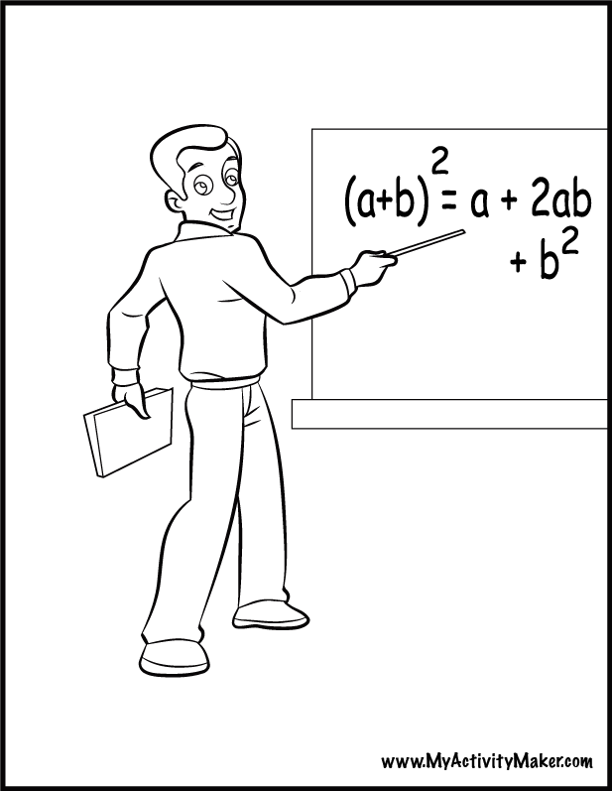**Match people to the belonging.**

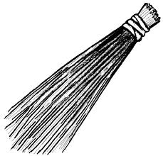

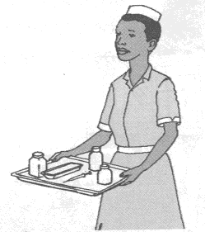

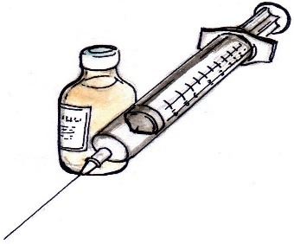[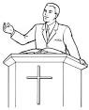](http://www.google.co.ug/imgres?imgurl=http://www.bible-printables.com/images/bible-sheet2.gif&imgrefurl=http://www.bible-printables.com/about.htm&usg=__UeFOW0iTYvx3XameWa_uLeDumrM=&h=309&w=250&sz=10&hl=en&start=156&zoom=1&tbnid=JWeLYhbhy3JylM:&tbnh=117&tbnw=95&ei=lX5_Ubf8IKjH7AaQ8oD4Cw&prev=/search?q=colourable+picture+of+someone+reading+the+bible&start=140&um=1&sa=N&hl=en&gbv=2&tbm=isch&um=1&itbs=1&sa=X&ved=0CEgQrQMwDziMAQ)

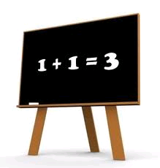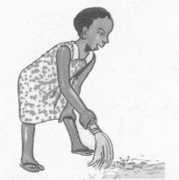

1. **. Trace and shade.**
2. **. Copy, draw and write.**

|  |  |  |  |
| --- | --- | --- | --- |
| pot    pot | a cup    cup | mat | ball |
|  |  |  |  |

1. **. Shade the dangerous objects.**

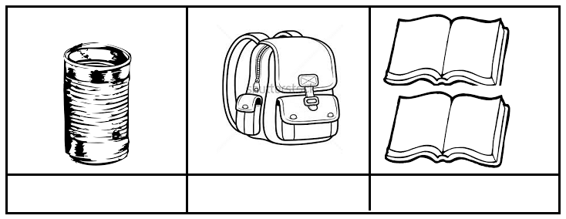

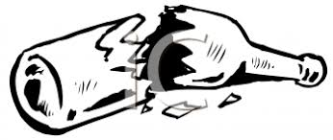

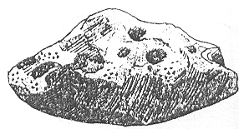

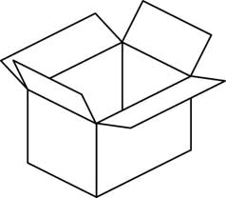



**“Good Luck”**